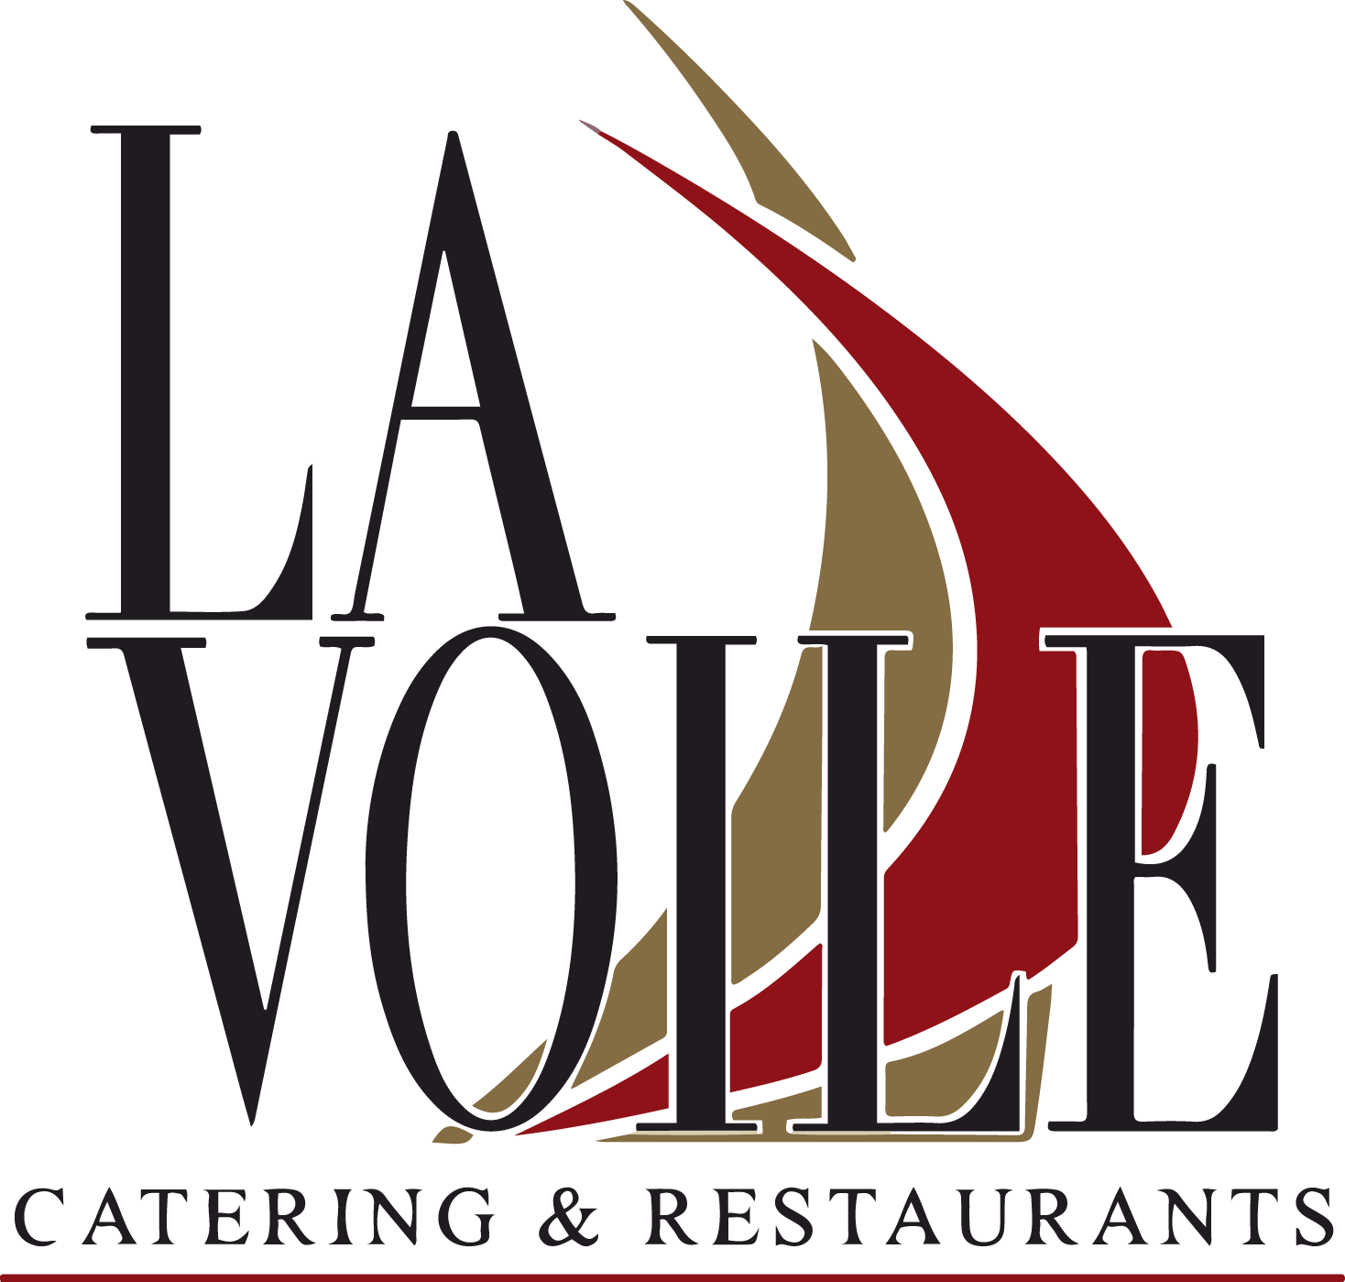

TASTE OF FRANCE
$45.00
We hope this menu will express our love for French cuisine and for you.

Le Terrine
Chicken Liver Mousse, Onion Compote & Cornichons, Toasted Pain d’Avignon.

La Soupe
Cold English Green Peas Soup, hint of Mint, Crème Fraîche Or Onion Soup Gratinée Or Fish Soup.

La Betterave
Roasted Beets, Mixed Greens, Shallots, Aged Goat Cheese & Dijonnaise.


Le Confit
Duck Confit With Potato Dauphinois Gratin, Chambord Sauce.

Le Cabillaud
Pan Seared Cod Fish Over Scallions Mashed Potatoes, Red Bell Pepper Coulis.

Le Risotto
Al Dente Arborio Rice, Sun Dried Tomatoes & English Green Peas, Parmesan Shaving.

Les Moules
P.E.I Mussels, Marinière Sauce, White Wine, Shallots & Parsley, Pomme Frites.

La Friandise Du Jour



COLD APPETIZERS
La Salade Verte Green salad, rosemary and thyme wrapped goat cheese & balsamic vinaigrette. 13
La Betterave Roasted beets, mixed greens, shallots, aged goat cheese
& dijonnaise. 14
Les Tomates Heirloom tomato mosaic with fresh mozzarella,
green pesto & aged balsamic. 15

La Charcuterie Duck rillettes, aged local cheese, smoked duck breast,
prosciutto, onion compote & cornichons. 18

Le Saumon Fumé Smoked salmon platter, mixed greens, cucumber carpaccio
& lemon oil. 14
La Terrine (Volaille) Chicken liver mousse, cornichons, shallots compote & field green salad. 12

Les Huîtres 6 oysters from Maine & mignonette sauce. 14
La Terrine
Foie Gras Terrine 16
Les Foie Gras
Le Pôelé
Pan Seared Foie Gras 16
Le Duo de Foie Gras
Both Foie Gras! 26

HOT APPETIZERS

La Soupe à l’oignon French onion soup, croûtons & elemental cheese. 12
Le Velouté Cold English green peas soup, hint of mint & crème fraîche. 11
La Soupe de Poisson Fish soup in tomato broth, garlic aioli & Swiss cheese. 13 Les Escargots Escargots bourguignons cooked in garlic & parsley butter. 13 Le Risotto Al dente arborio rice, sun dried tomatoes, English green peas
& parmesan shaving. 14 / 18

Before placing your order, please inform your server if anyone in your party has a food allergy. All stocks in sauces and soups are prepared in house and made with the freshest ingredients
*Consuming raw or undercooked meats, poultry, seafood, shellfish and eggs may increase your risk of food-born illness.
**Denotes food items are cooked to order or are served raw


WINE FLIGHT
Discover a selection of Red or White wines, their story through four sampling assortment. $16

LA MER
Le Saumon Pan seared salmon filet, sautéed spinach, basmati rice & choron sauce. 28

Le Cabillaud Pan seared cod fish over scallions mashed potatoes & red bell pepper coulis. 26

La Sole Dover sole meunière seared in hazelnut butter, capers & lemon, accompaniment of truffle mashed potatoes. 44

Les Moules Frites P.E.I mussels in spicy saffron, creamy curry or in a traditional marinière sauce, side of pommes frites. 22

Sides ($6 Each)
Sautéed Spinach, Gratin Dauphinois, Haricots Verts, Pommes Frites, Mixed Mushrooms, Rosemary Polenta, Mashed Potatoes, Fingerling Potatoes, & Basmati Rice.

LA TERRE
Le Canard Roasted duck breast*, fingerling potatoes, haricots verts & Chambord sauce. 26

L’Agneau Pan seared rack of lamb*, rosemary polenta, sautéed
mushroom, garlic & rosemary jus. 41

Le Bourguignon Braised beef shoulder in a red wine aromatic broth, pearl onions, mushrooms, baby carrots & mashed potatoes. 25

Le Filet de Boeuf Pan seared beef tenderloin*, sautéed fingerling potatoes, spinach oyster mushrooms & truffle mirepoix. 38

Le Confit Duck confit*, gratin dauphinois, green field salad
& cassis sauce. 25

La Volaille Half roasted free range Crystal Valley Chicken, chickpeas,
(Cooking time 35min) artichoke fricassée, green beans & garlic thyme sauce. 26



FRENCH LILLET APERITIF WHITE / RED / ROSE / $11

Les Blancs

Chenin Blanc
LES VINS AU VERRE

13

Clos Palet, “Vouvray” Loire 2018
Chardonnay 14
Joseph Drouhin, “Chablis” Bourgogne 2019
Sauvignon Blanc 11
Reserve Durand, “Sauvignon Blanc" Loire 2020
Sauvignon Blanc
Reserve Durand “Sancerre” Loire 2019 14
Les Rosés
Grenache / Syrah / Cinsault / Cargnan 12
“Clémentine” Cotes de Provence 2019
Cinsault / Grenache 14
Maison Parel “Cuvée Mistral” Méditerranée 2020
Les Rouges
Pinot Noir 14
“Laforet” Joseph Drouhin, Pinot Noir 2018
Grenache / Syrah / Mourvèdre 14
“La Solitude” Côtes du Rhône 2019 Malbec
“Le Vassal De Mercuès” Malbec 2018 12
Cabernet Franc
“Bourgueil” Cuvée Déchainée Bourgueil 2019 13
Cabernet Sauvignon / Merlot
“Château Cardus” Bordeaux 2016
15
Les Bulles

Crémant de Limoux
Domaine Collin, Brut, Languedoc 11
Crémant de Limoux
Domaine Collin, Brut Rosé, Languedoc Rosé 12
Moët & Chandon
Impérial, Champagne 187 ML 22
Nicolas Feuillatte
Reserve Exclusive, Champagne 187 ML Rosé 26

